DESIGN AND ANALYSIS OF ALGORITHM
NAME: NIVASINI VM
REG NO : 192511356
CO 4 -ASSESMENT TOOL 2
Q26. Fraud Detection Transaction Analysis (Pattern Matching + Optimization)
A financial institution must analyze millions of transactions to detect fraudulent activities in real time. Analyze how pattern matching and anomaly detection algorithms can be applied. Identify constraints such as data volume, processing speed, and accuracy. Design a solution using efficient string or sequence matching techniques. Discuss implementation using scalable platforms. Evaluate time complexity and detection performance. Interpret results in terms of risk reduction and system reliability. Prepare your solutions according to the rubric provided in the Question Bank.
Answer
1. Introduction
Fraud detection is the process of identifying unauthorized or suspicious financial transactions. Since financial institutions handle millions of transactions every day, the detection system must work quickly and accurately. Pattern matching can be used to identify known fraudulent transaction patterns, while anomaly detection can identify unusual behavior that differs from a customer's normal activity.
2. Understanding the Problem and Constraints
The main objective is to examine every transaction and determine whether it is legitimate, suspicious, or fraudulent. The major constraints are large data volume, high processing speed, detection accuracy, changing fraud patterns, scalability, reliability, and security. The system should process a large number of transactions within a short time while keeping false positives and false negatives as low as possible.
3. Proposed Solution
A hybrid fraud detection system can combine pattern matching, sequence matching, rule-based detection, anomaly detection, and risk scoring. Incoming transactions are first collected through a real-time streaming system. The transaction data is then checked against known fraud patterns and analyzed for unusual behavior. The results are combined to produce a risk score. Low-risk transactions can be approved, medium-risk transactions can be sent for additional verification, and high-risk transactions can be blocked or reported for investigation.
CODE
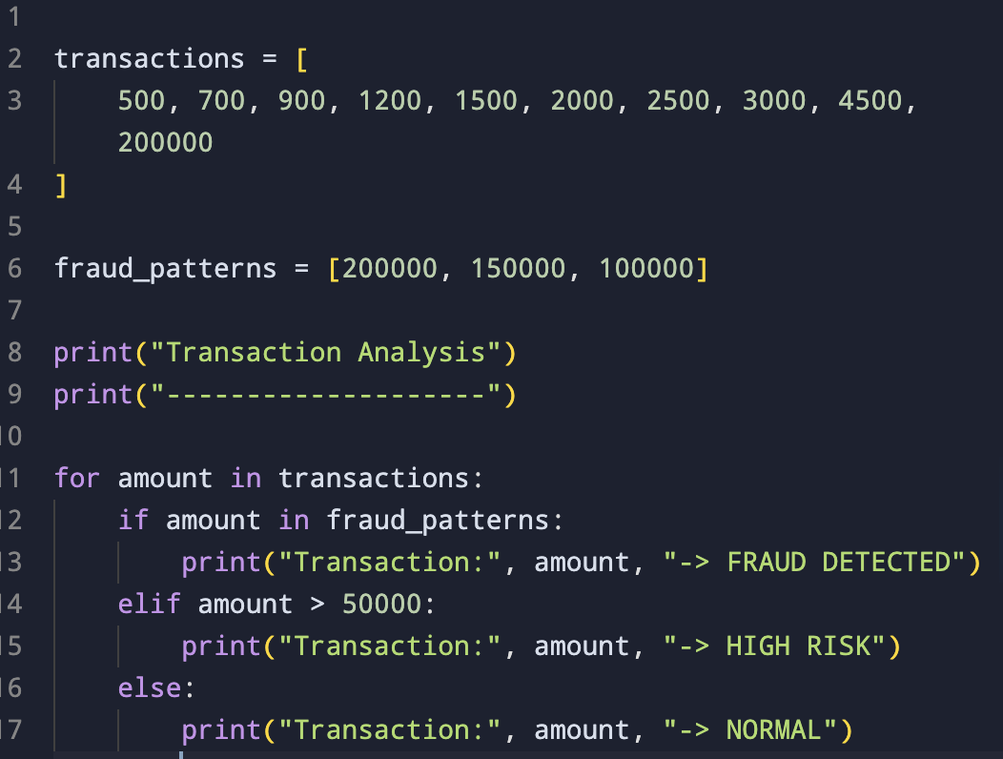
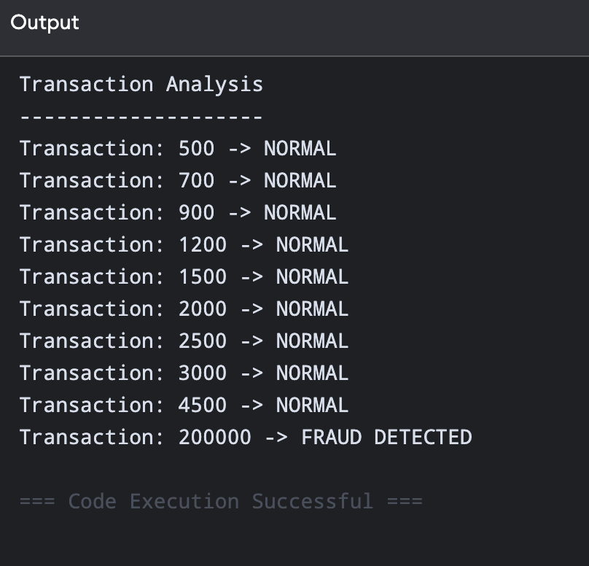
4. Pattern Matching
Pattern matching is useful for detecting fraud patterns that are already known. For example, a sequence such as Login followed by New Device, Password Change, and a Large Transfer can be considered suspicious. Algorithms such as KMP (Knuth-Morris-Pratt), Rabin-Karp, Boyer-Moore, and Aho-Corasick can be used. Aho-Corasick is particularly useful when many fraud patterns must be searched at the same time.
5. Sequence Matching
Fraud may not always be identified from a single transaction. A sequence of transactions can provide stronger evidence. For example, a customer's normal transactions may be between ₹500 and ₹5,000, followed suddenly by a transaction of ₹50,000 from a new location and device. The system can use a sliding window containing recent transactions, such as transactions from the last 10 transactions, 30 minutes, or 24 hours. Features such as amount, location, device, IP address, time interval, merchant category, and transaction history can be compared.
6. Anomaly Detection
Anomaly detection identifies transactions that are significantly different from normal customer behavior. Algorithms such as Isolation Forest, One-Class SVM, Local Outlier Factor, clustering, and autoencoders can be used. For example, if a customer normally makes transactions below ₹5,000 but suddenly makes a transaction of ₹2,00,000 from a new device, the transaction can receive a high anomaly score.
7. Risk Scoring
The results from pattern matching and anomaly detection can be combined to calculate a risk score. The score may consider transaction amount, location, device, transaction frequency, and pattern matching. For example, a score below 30 can be treated as low risk, a score between 30 and 70 as medium risk, and a score above 70 as high risk. These values are only example thresholds and should be selected using historical data.
8. Optimization Techniques
Several optimization techniques can improve the performance of the system. Hashing can provide fast access to customer, device, and transaction information, with average lookup time of O(1). Database indexing can speed up searches using fields such as Customer ID, Transaction ID, Device ID, Timestamp, and Merchant ID. Sliding windows reduce unnecessary processing by considering only relevant recent transactions. Caching can store frequently used customer risk profiles and device information. Parallel processing can divide transactions among several processing nodes so that many transactions are analyzed at the same time.
9. Scalable Platform Implementation
A scalable implementation can use Apache Kafka for real-time transaction streaming and Apache Spark Structured Streaming or Apache Flink for distributed processing. Transactions can be sent to Kafka and processed by multiple workers. The workers perform pattern matching, anomaly detection, and risk scoring. The final decision can then be stored in a database or data lake. Cloud infrastructure can also be used to increase the number of processing instances when the transaction load increases.
10. Working Procedure
For every incoming transaction, the system extracts the required features and checks the transaction against known fraud patterns. It then calculates the anomaly score and other risk values. These values are combined to produce the final risk score. If the score is high, the transaction is blocked and an alert is generated. If the score is medium, additional authentication can be requested. If the score is low, the transaction is approved. The transaction and its result are stored for future analysis.
11. Time Complexity
For a text or sequence of length n and a pattern of length m, simple or naive pattern matching can require O(nm) time. KMP reduces this to O(n + m) for a single pattern. Aho-Corasick can search multiple patterns in approximately O(n + total pattern length + number of matches). Therefore, efficient pattern matching is more suitable for large-scale fraud detection. With k processing nodes, the practical processing workload can be distributed approximately as O(n/k), although communication and coordination introduce some additional overhead.
12. Detection Performance Evaluation
The system should be evaluated using precision, recall, F1 score, detection latency, throughput, false-positive rate, false-negative rate, and system availability. Precision measures how many transactions identified as fraud are actually fraudulent. Recall measures how many actual fraudulent transactions are successfully detected. The F1 score provides a balance between precision and recall. Detection latency and transactions processed per second are especially important for real-time financial systems.
13. Example Result
Suppose the system processes 1,000,000 transactions and identifies 9,500 transactions as suspicious. After investigation, 8,700 are confirmed as fraudulent and 800 are found to be legitimate. This information can be used to calculate the precision of the system and adjust the detection rules or model. If most fraudulent transactions are detected quickly while unnecessary alerts are kept low, the system can be considered effective.
14. Risk Reduction and Reliability
The proposed system reduces financial risk by identifying suspicious transactions at an early stage. Real-time monitoring, pattern matching, anomaly detection, risk-based authentication, and automatic blocking can reduce fraudulent losses. Reliability can be improved through replicated data, load balancing, distributed processing, fault-tolerant nodes, backup, recovery, monitoring, and logging. If one processing node fails, other nodes can continue processing the transactions.
15. Advantages
The system can handle millions of transactions efficiently and support real-time fraud detection. It can identify both known and previously unseen fraud patterns. It can reduce unnecessary blocking through risk-based decisions and can be scaled by adding processing nodes. Distributed processing and replication also improve availability and reliability.
16. Conclusion
A hybrid fraud detection system that combines efficient pattern matching with anomaly detection provides a practical solution for analyzing large volumes of financial transactions. Algorithms such as KMP and Aho-Corasick improve pattern-search efficiency, while anomaly detection helps identify new and unusual fraud behavior. Using scalable technologies such as Kafka, Spark, or Flink allows the system to process transactions in real time and at large scale. The proposed approach improves detection accuracy, reduces financial risk, and provides a reliable foundation for real-time fraud prevention.

